Trivandrum Branch Page - Content

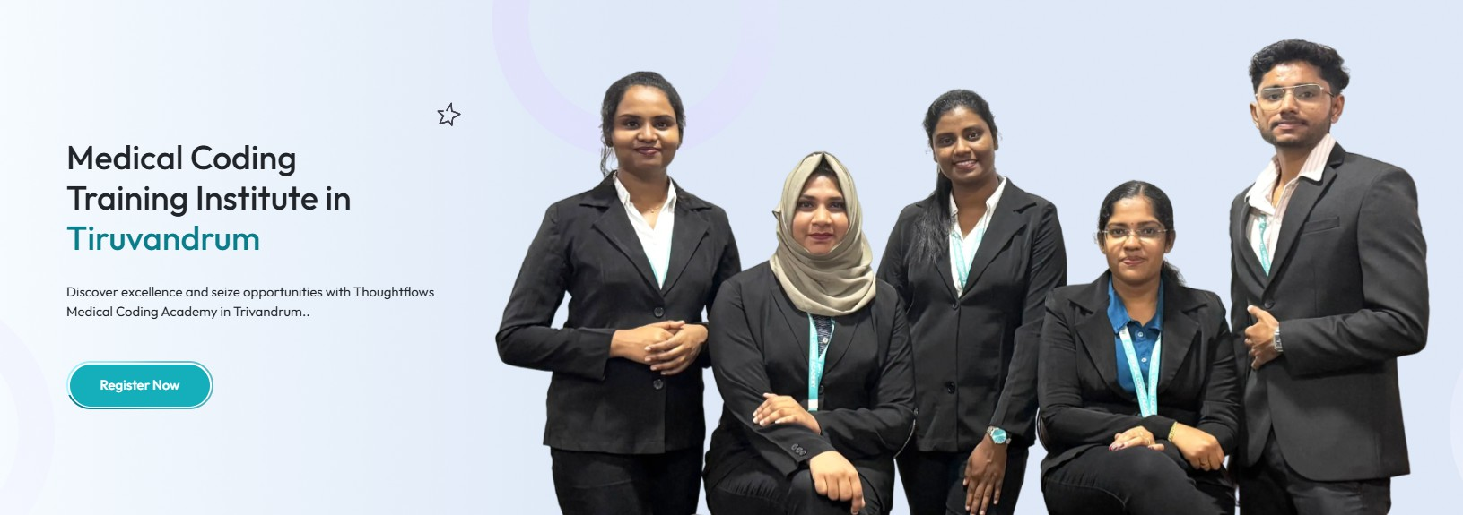

1.Medical Coding Course in Trivandrum with Placement Support
Become a Certified Medical Coder with Expert Training, CPC Certification Guidance, Practical Coding Experience, and Career Support from ThoughtFlows Medical Coding Academy.
- CTA Button: Book Free Demo Class

- Need to change image - Employee image instead of Students image

2.


✅ 35,000+ Students Trained
✅ 25,000+ Placements Assisted
✅ Online & Classroom Training
✅ CPC Certification Guidance

✅ Interview Preparation & Placement Support

3.
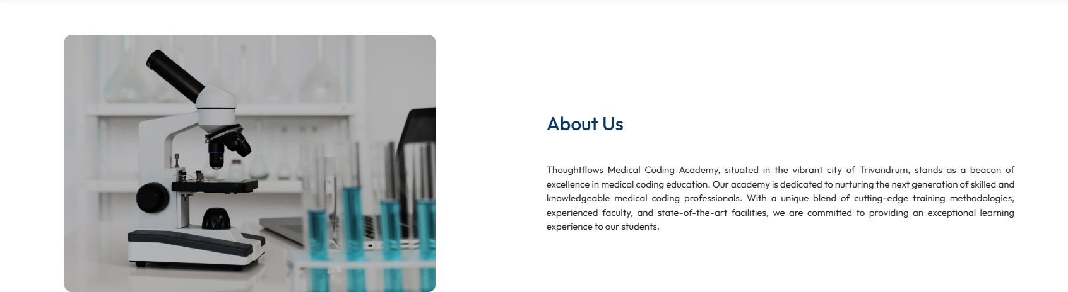
- Need to change image

- Why Choose Medical Coding as a Career?

Medical Coding is one of the fastest growing healthcare careers. Benefits:
  - Healthcare industry career
  - Work with multinational companies
  - Attractive starting salaries
  - Opportunities in India and abroad
  - Career growth through CPC, CCS and specialty certifications
  - Suitable for Life Science, Pharmacy, Nursing, BDS, BHMS and Allied Health graduates

Who Can Join This Course?
This course is suitable for:

  - B.Sc Life Science Graduates
  - B.Pharm Graduates
  - D.Pharm Graduates
  - Nursing Graduates
  - BDS Graduates
  - BHMS Graduates
  - Physiotherapy Graduates
  - Fresh Graduates interested in Healthcare Careers No prior coding experience required.

Why Choose ThoughtFlows Medical Coding Academy in Trivandrum?
ThoughtFlows is committed to helping students build successful careers in the healthcare industry through industry focused training and career development support. With 35,000+ students trained and 25,000+ career placements and transitions supported, the academy has established itself as a trusted name in Medical Coding education.
Students benefit from experienced trainers, practical coding sessions, CPC certification guidance, interview preparation, flexible learning options, and placement focused training. Many students looking for Medical Coding Training in Kerala choose ThoughtFlows because of its structured learning approach, career focused support, and commitment to student success. Our training methodology helps learners develop the knowledge and confidence required to pursue opportunities in the healthcare industry.

Medical Coding Training in Trivandrum
Medical Coding has become one of the most sought after healthcare careers for Life Science, Pharmacy, Nursing, and Allied Health graduates. As healthcare services continue to expand across Kerala and India, the demand for trained Medical Coding professionals continues to grow.
Students looking for a Medical Coding Course in Trivandrum often seek industry focused training, certification guidance, and career support. Our training program covers medical terminology, anatomy, physiology, ICD-10-CM, CPT, HCPCS, and CPC exam preparation to help learners develop industry-relevant skills.
Many aspiring healthcare professionals across Kerala choose Medical Coding as a career because of its growing demand and long term career opportunities.
Students searching for a Medical Coding Course in Kerala often look for practical learning, certification focused preparation, and career development support.
Through structured training and hands on learning, learners can prepare for opportunities in hospitals, healthcare BPOs, revenue cycle management companies, healthcare technology organizations, and global healthcare markets.

CPC Certification Guidance
The Certified Professional Coder (CPC) credential is one of the most recognized Medical Coding certifications in the healthcare industry. CPC certification validates coding knowledge and demonstrates professional competency in medical coding practices.
ThoughtFlows provides CPC focused training designed to help students understand coding concepts, medical documentation, coding guidelines, and exam oriented preparation. With expert guidance and structured learning, students can strengthen their coding knowledge and prepare confidently for certification goals

Career Path Roadmap
Medical Coding Training
↓
CPC Certification Preparation
↓
Medical Coder

₹2.5–4.5 LPA
↓
Senior Medical Coder

₹4–7 LPA
↓
Quality Analyst

₹6–10 LPA
↓
Team Lead

₹8–15 LPA
↓
Coding Manager
₹12–25+ LPA

Placement Support & Career Growth Opportunities
With 35,000+ students trained and 25,000+ career placements and transitions supported, ThoughtFlows has helped aspiring healthcare professionals build successful careers in the Medical Coding industry.
Recognized as a trusted Medical Coding training provider, ThoughtFlows has earned a reputation among students seeking quality healthcare career education. Its focus on practical learning, CPC certification guidance, and placement focused support has helped establish it as one of the best Medical Coding Institute in Kerala for aspiring Medical Coding professionals.
Whether you are a fresher starting your career journey or an experienced healthcare professional seeking career advancement, our training programs provide practical learning and career-focused guidance to help you pursue opportunities in the healthcare industry.
Our dedicated placement support team assists students with resume building, interview preparation, mock interviews, HR guidance, career counseling, and job referral support.
Medical Coding professionals can explore opportunities in hospitals, healthcare BPOs, revenue cycle management (RCM) companies, medical coding organizations, healthcare technology companies, insurance support

services, and health information management organizations across India and global healthcare markets.
With the continued growth of the healthcare sector, Medical Coding professionals have opportunities across Kerala, Chennai, Bangalore, Hyderabad, Pune, Mumbai, Noida, and other major healthcare destinations. Professionals with strong coding skills and recognized certifications may also explore opportunities with international healthcare organizations and global healthcare service providers.

Online & Classroom Training Options
Students can choose between online and classroom training based on their learning preferences and schedules. Flexible batch timings help fresh graduates, students, and working professionals pursue Medical Coding Training in Trivandrum while balancing their academic or professional commitments. Students evaluating a Medical Coding Course Trivandrum often prefer flexible learning options that allow them to learn without disrupting their studies or work schedules.

Remove this content

Rewrite

Instead of

Practical Learning Environment

Students gain practical exposure to medical coding concepts through hands-on learning, real world coding scenarios, and industry relevant training methodologies. This practical approach helps learners develop the skills and confidence required for a successful healthcare career.

Rewrite

Instead of

Flexible Learning Options

Online and classroom training options are available to support different learning preferences. Flexible batch schedules help students, fresh graduates, and working professionals pursue Medical Coding training while balancing their academic or professional commitments.

Remove these content

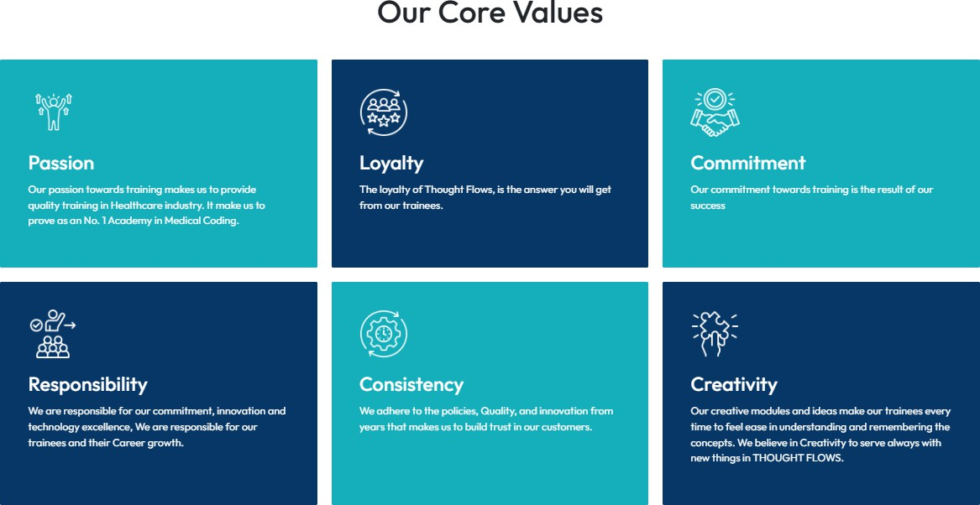

Change this image


FAQ

What is the basic qualification for learning medical coding?
Any graduates from life science non Life science background & paramedical diploma holders can learn medical coding.

Is there demand for Medical Coders?
Yes. The healthcare industry has a growing demand for skilled Medical Coders, both in India and abroad.

How long does the course take?
The duration typically ranges 3 months. & Daily having 2 hours classes, both weekdays & weekends available. Depending on the course you choose,it will vary the duration.

Will I get placement support?
Yes. We're providing placements across India. There'll be interview preparation, resume guidance, HR sessions, Communication & behaviour sessions, Mock interviews etc.

Is CPC certification mandatory?
CPC certification is not mandatory, but it is highly recommended as it enhances career opportunities and increases employability. It is a globally recognized certification that can open doors to better job prospects, higher salary packages, and opportunities to work with international healthcare organizations, including abroad. Having a CPC certification adds significant value to your profile and helps you stand out in the Medical Coding industry.

